Scavenger Hunt
Use the website to answer the following questions.
 | Hint | Answer
- How many steps are there to making candles? | Settler Life
- What is this farmer doing?  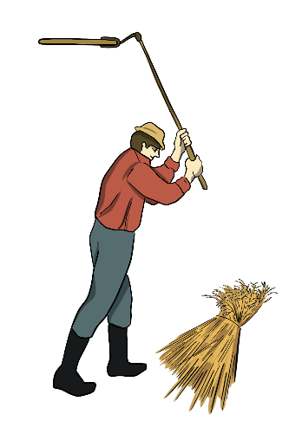 | Farming
- Which oilseed crop do we get mayonnaise from? | Present - Crops
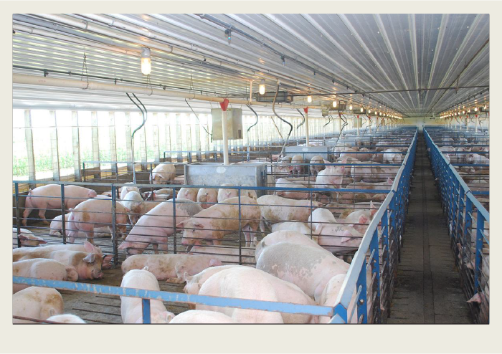  - Why do pigs often live in barns? | Present - Animals
- How many farms are in Saskatchewan (as of 2016)? | Present – Type of Farms - Mixed Farms

- Why did people become ill during the drought of the Great Depression?  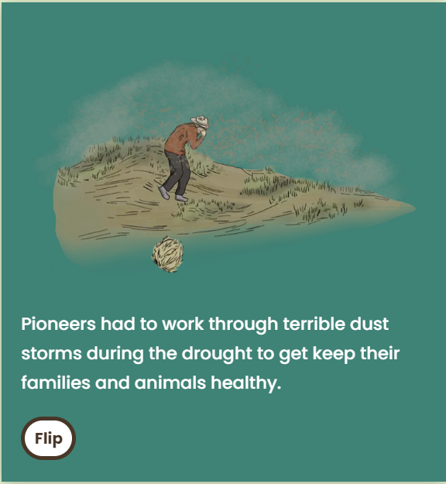 | Past – Great Depression
- Who did the Peasant Policy affect? | Past – Farming Challenges
- What was this called?  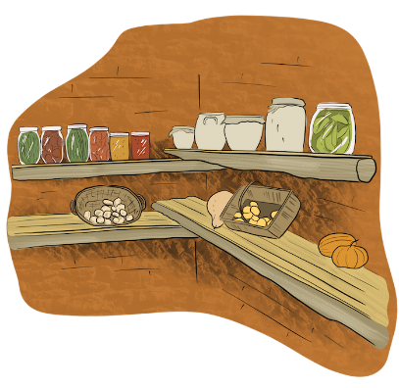 | Past – Settler Life
- Who was Mattie Mays? | Past – Towns (she knew a lot about herbal medicine)
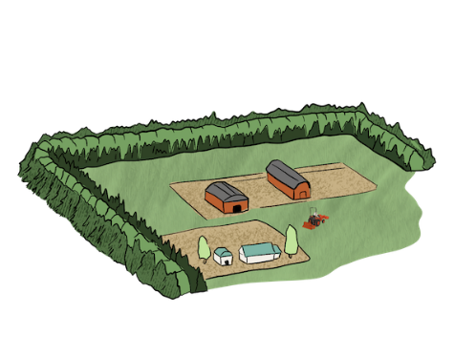  - What do trees planted in rows like this do? | Past – Great Depression

